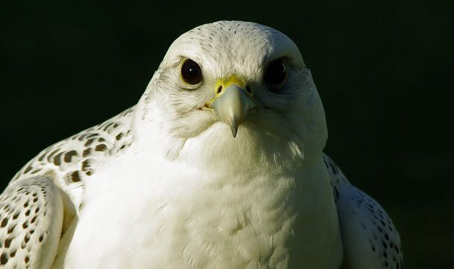
Basic and Advanced Course on Raptor Medicine

The Faculty of Veterinary Medicine of Parma University, Italy, offers a five-day full-time course on Basic and Advanced Raptor Medicine and Surgery. Lectures will be combined with practical laboratories. The course is intended for post-graduate professionals and will be taught entirely in English.

The course will be held at the Department of Veterinary Medicine of the University of Parma, Strada del Taglio, 10-43126, Parma, Italy from 10th June to 14th June. The maximum number of places available is 40. The degree required for enrollment in the course is a Bachelor in Veterinary Medicine.

Managing Director
Professor Maurizio Dondi (maurizio.dondi@unipr.it)

Administrative Coordinator
Maria Luisa Ghelfi (marialuisa.ghelfi@unipr.it).

Guest Professor
Paolo Zucca DVM, PhD Physiology and Ethology, BSc Psychology

Veterinary Officer, Veterinary Public Health Service, Central Directorate for Health, Social Health Integration, Social Policies and Family - Friuli Venezia Giulia Autonomous Region.
Veterinary Surgeon recognized by the National Chamber of Veterinary Surgeon of Italy (FNOVI) in the field of Exotic and Wildlife Animal Medicine and Surgery.
Course Professor

Jaime Samour, MVZ (Hons) Ph.D., Dip ECZM (Avian)
Diplomate European College of Zoological Medicine (Avian)
IUCN SSC Wildlife Health Specialist Group
AAV Regional Representative Middle East and North Africa
Director of Wildlife, Al Taf, Wildlife Division, Office of HH Sheikh Sultan bin Zayed Al Nahyan, Abu Dhabi, United Arab Emirates

Programme

Day 1

08:00 – 09:00
Registration

09:00 – 10:00
Module 1. Introduction to Raptors
- Evolution
- Taxonomy

10:00 – 11:00
Module 2. Structure and Function
- Anatomy
- Physiology

11:00- 11:30
Coffee break

11:30 – 12:30
Module 3. Avian Brain: Avian Cognition and Welfare 1

12:30 – 14:00
Lunch break

14:00 – 15:00
Module 4. Avian Brain: Avian Cognition and Welfare 2

15:00 – 16:00
Module 5. Neurophysiology of vision and senses

16:00 – 16:30
Coffee break

16:30 – 17:30
Module 6. Neurophysiology of hearing

17:30 – 18:30
Module 7. Housing and Husbandry

Day 2

09:00 – 10:00
Module 8. Patient Examination
- Physical examination
- Clinical examination

10:00 –11:00
Module 9. Sedation and Anaesthesia
- Handling
- Sedation
- Anaesthesia

11:00 – 11:30
Coffee break

11:30 – 12:30
Module 10. Medical, Nursing and Cosmetic Procedures 1
- Medicament administration
- Biomedical sampling
- Nasal and sinal flushing
- Gastric lavage
- Dressings and bandaging

12:30 – 14:00
Lunch break

14:00 -15:00
Module 11. Medical, Nursing and Cosmetic Procedures 2
- Stomach tube placement
- Force feeding
- Beak and talon trimming
- Feather repair

15:00 - 16:00
Module 12. Post-Mortem Examination

16:00 – 16:30
Coffee break

16:30 – 18:30
Practical workshop
- Feather repair

Day 3

09:00 – 10:00
Module 13. Clinical Diagnostic Examination 1
- Radiology

10:00 – 10:30
Coffee break

10:30 – 12:30
Practical workshop
- Radiology

12:30 – 14:00
Lunch break
14:00 – 15:00
Module 14. Clinical Diagnosis Examination 2
- Endoscopy

15:00 – 15:30
Coffee break

15:30 - 17:30
Practical workshop
- Endoscopy

Day 4

09:00 – 10:00
Module 15. Soft Tissue Surgery

10:00 – 10:30
Coffee break

10:30 – 12:30
Practical workshop
- Soft Tissue Surgery

12:30 – 14:00
Lunch break

14:00 -15:00
Module 16. Traumatology

15:00 – 15:30
Coffee break

15:30 – 18:30
Practical workshop
- Traumatology

Day 5

09:00 – 10:00
Module 17. Clinical Diagnostic Laboratory 1
- Haematology
- Blood chemistry

10:00 – 11:00
Module 18. Clinical Diagnostic Laboratory 2
- Parasitology
- Cytology

11:00 – 11:30
Coffee break

11:30 – 12:30
Module 19. Infectious Diseases 1
- Viral diseases
- Bacterial diseases

12:30 – 14:00
Lunch break

14:00 – 15:00
Module 20. Infectious Diseases 2
- Fungal diseases
- Parasitic diseases

15:00 – 16:00
Module 21. Non-Infectious Diseases
- Toxicosis
- Metabolic

16:00 – 16:30
Coffee break

16:30 – 18:30
Practical workshop
- Haematology

18:30 - 19:00
Course closure and farewell

The city of Parma
Parma is a city in the northern Italian region of Emilia-Romagna famous for its food, architecture, music and surrounding countryside. The City is home to the University of Parma, one of the oldest universities in the world. Parma is divided into two sections by the stream of the same name. The average annual high temperature is 17°C (63 F), the annual low temperature is 9 C (48 F), and the annual precipitation is 777 mm (30.59 inches). Parma is famous for its rich gastronomical tradition including the world famous Parmigiano Reggiano cheese (also produced in Reggio Emilia) and Prosciutto di Parma (Parma ham). You could never say that you have been to Parma if you did not try such typical pasta dishes like "tortelli d'erbetta" and "anolini in brodo".

How to reach Parma

Air-bus-train travel
For international visitors, the best way to reach Parma is to fly first to Milano Malpensa Airport. The airport is serviced by numerous airlines from all over the world. The airport is 53 km away from the city of Milano. On arrival, visitors can then proceed to the arrival terminal and buy a bus ticket, at a very modest price, from the various bus service stalls available at the terminal. From Milano Central Station visitors can take a train directly to Parma. There are over 30 trains travelling to Parma every day. The trip lasting just over 1 hour.

Taxi travel
A very useful way to reach Parma is through the services of a private taxi Company. Such Company would pick you up at Milano Malpensa Airport and take you directly to the Hotel of your choice in Parma. If you book way in advance the total cost is relatively low. Please see https://www.goopti.com/it/

Where to stay

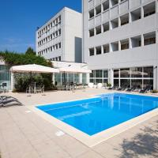 Best Western Plus Hotel Farnese
4-star hotel This is a Preferred property. They provide excellent service, a great value, and have awesome reviews from Booking.com guests. They might pay Booking.com a little more to be in this program.
Parma (0.7 km from "Strada del Taglio, 10, Parma, Province of Parma, Italy")
The only hotel with an outdoor swimming pool in central Parma, Best Western Hotel Farnese is one mile from Palazzo della Pilotta and 2 miles from Parma Cathedral.

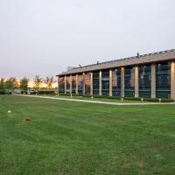 Hotel City Parma
4-star hotel This is a Preferred property. They provide excellent service, a great value, and have awesome reviews from Booking.com guests. They might pay Booking.com a little more to be in this program.
Parma (0.9 km from "Strada del Taglio, 10, Parma, Province of Parma, Italy")
The Hotel City Parma is a period farmhouse in the countryside, just over a quarter mile from Giuseppe Verdi Airport and 2 miles from Parma's historic center. It has free parking and large rooms.

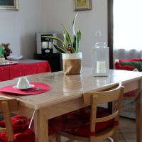 B. & B. NABUCCO
Parma 0.9 km from "Strada del Taglio, 10, Parma, Province of Parma, Italy")
Located 0.9 miles from Parma Hospital, B. & B. NABUCCO in Parma provides rooms with air conditioning and free WiFi.

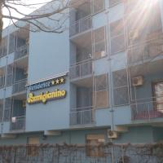 Residence Parmigianino
Parma (1.2 km from "Strada del Taglio, 10, Parma, Province of Parma, Italy")
Located in Parma, 0.6 miles from Parma Hospital, Residence Parmigianino provides accommodations with air conditioning and access to a garden. Complimentary WiFi is provided.

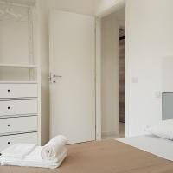 FWS rooms&apartments A2
Parma (1.3 km from "Strada del Taglio, 10, Parma, Province of Parma, Italy")
FWS rooms&apartments A2 is a self-catering property located in Parma near Parco Ducale. This apartment has a fitness center as well as a terrace.

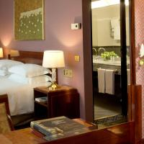 Starhotels Du Parc
4-star hotel This is a Preferred property. They provide excellent service, a great value, and have awesome reviews from Booking.com guests. They might pay Booking.com a little more to be in this program.
Parma (1.3 km from "Strada del Taglio, 10, Parma, Province of Parma, Italy")
Directly connected by a bridge to Parma's Parco Ducale, Starhotels Du Parc is set in a historic building known as the Ice Factory. It offers 2 restaurants, a bar and free WiFi throughout.

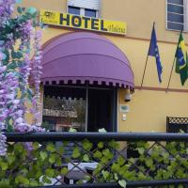 Hotel Violetta
1-star hotel
(1.4 km from "Strada del Taglio, 10, Parma, Province of Parma, Italy")
Hotel Violetta is located in Parma and it features free WiFi throughout and classic-style rooms. Parma Train Station is 2 km away. The rooms are provided with a flat-screen TV and work desk.

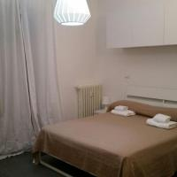 Guesthouses Sunny Home
Parma–(1.4 km from "Strada del Taglio, 10, Parma, Province of Parma, Italy")
SWEET PARMA is situated in Parma, 1.1 km from Parma Hospital and 300 metres from Parco Ducale. The property is set 5 km from Fiere di Parma, 2.1 km from Ennio Tardini and 4.4 km from Kartodromo.

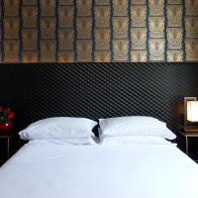 Hotel Verdi
4-star hotel
Parma (1.4 km from "Strada del Taglio, 10, Parma, Province of Parma, Italy")
Elegant Hotel Verdi is set in the historical centre of Parma, just 130 metres from Palazzo Ducale and 20 minutes' walk from the cathedral.

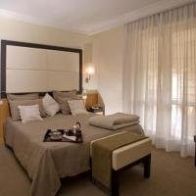 Hotel Daniel
3-star hotel
Parma (1.4 km from "Strada del Taglio, 10, Parma, Province of Parma, Italy")
The 3-star Hotel Daniel is a 3-minute walk from Parma University, the Ducale Park and Ospedale Maggiore hospital. Buses stop nearby and run regularly to the train station, which is 2 km away.

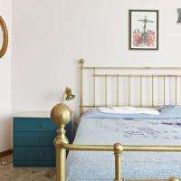 Guesthouses Lombardi Fleming
Parma (1.5 km from "Strada del Taglio, 10, Parma, Province of Parma, Italy")
Lombardi is located in Parma and has free parking on site. A bus stop, 200 metres from the property, offers links to Parma’s centre, including Piazza Duomo.

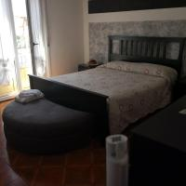 Guesthouses Vivi parma
Parma (1.5 km from "Strada del Taglio, 10, Parma, Province of Parma, Italy")
Providing free WiFi, Vivi parma offers accommodations in Parma, 1.1 miles from Parma Hospital and 700 yards from Parco Ducale.

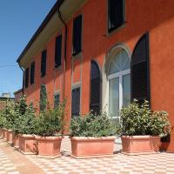 Residence Corte della Vittoria
Parma (1.5 km from "Strada del Taglio, 10, Parma, Province of Parma, Italy")
Only 1 km from Parma Airport, Residence Corte della Vittoria provides free parking and apartments with kitchenette and free Wi-Fi. Central Parma is less than a 10-minute drive away.

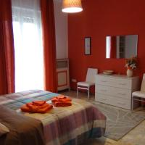 Apartment Ponte delle Nazioni
This is a Preferred property. They provide excellent service, a great value, and have awesome reviews from Booking.com guests. They might pay Booking.com a little more to be in this program.
Parma (1.5 km from "Strada del Taglio, 10, Parma, Province of Parma, Italy")
Offering free WiFi, Apartment Ponte delle Nazioni is a self-catering accommodation just 400 metres from Parma Train Station. The historic centre of Parma is a 10-minute walk away.

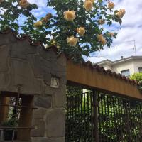 Apartment Viky's Sweet Home
(1.6 km from "Strada del Taglio, 10, Parma, Province of Parma, Italy")
Located in Parma, 1.4 miles from Parma Hospital, Viky's Sweet Home has a living room with a flat-screen TV, and free WiFi. The property is 0.6 miles from Parco Ducale.

We hope to see you in Parma next summer!

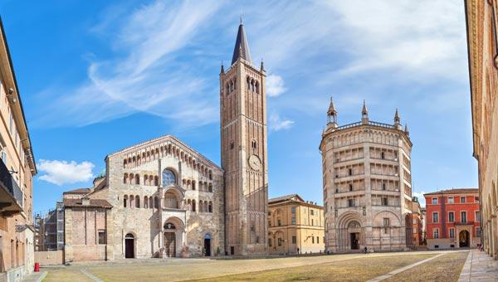

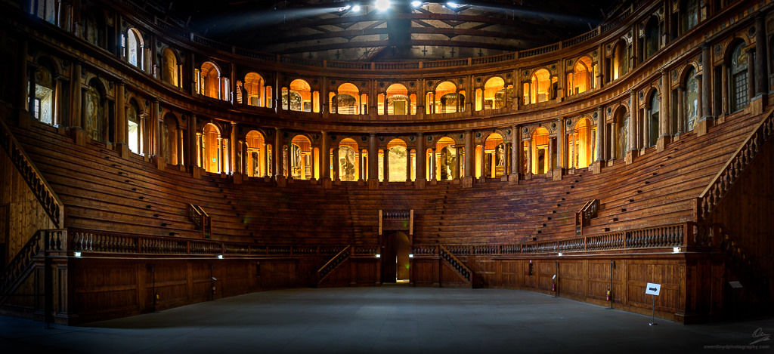

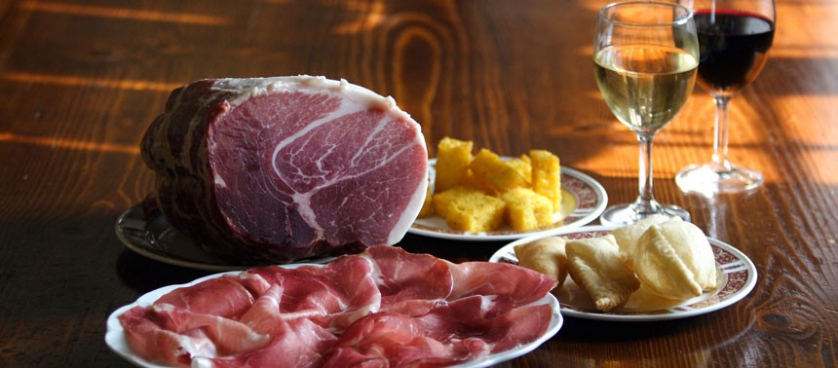

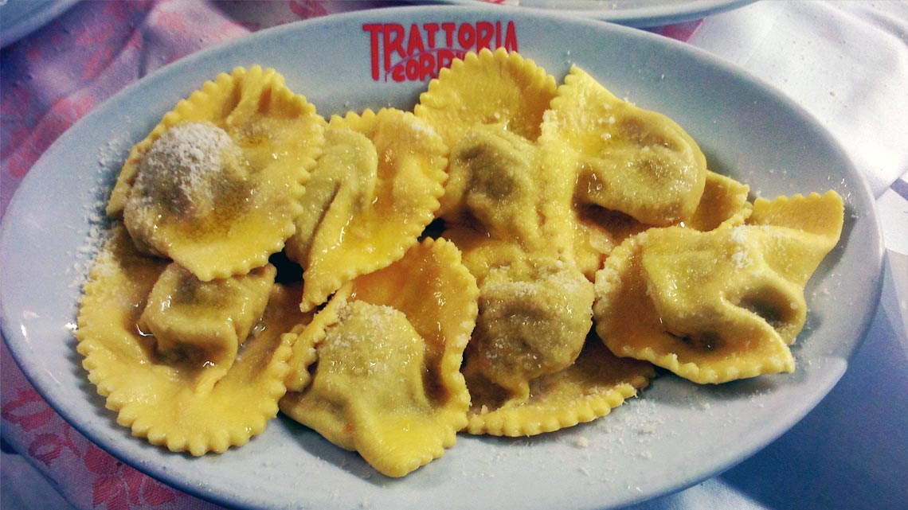

Buon appetito!

